Financial Dashboard

Final Outcome

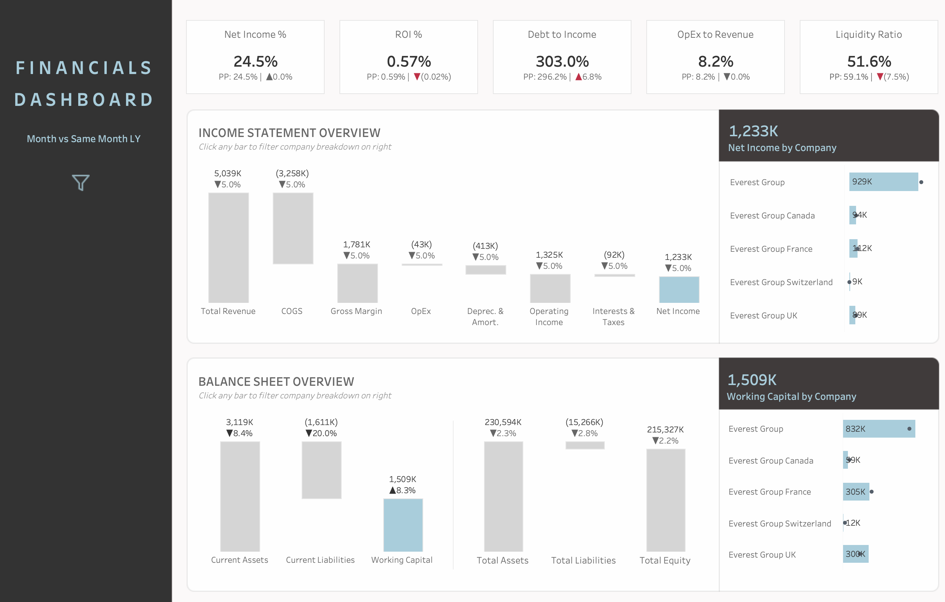

Dataset

Period Filters

**Current Period Filter**

1. Create a Parameter p.Time Period like below
   1. Graphical user interface

      Description automatically generated
   2. Finding the max date to find the latest date
   3. Graphical user interface, text, application

      Description automatically generated
   4. Create a min calculated field to find the start period. Date Trunc gives the first date and that’s why it is taken as min date.
   5. Graphical user interface, text, application, website

      Description automatically generated
   6. Finally create the filter that takes the data between min and max date
   7. Graphical user interface, text, application

      Description automatically generated

Here c.CP Filter picks up what Period (month / quarter/ year) end user is choosing to view the dashboard.

**Compare with Filter (Previous Period Filter)**

1. Create parameter p.Compare With like below
   1. Graphical user interface

      Description automatically generated
   2. Find the max date of previous period as per the calculated field below
   3. Graphical user interface, text, application

      Description automatically generated
   4. Create the min date field for previous period
   5. Graphical user interface, application

      Description automatically generated
   6. Create the PP Filter

KPIs

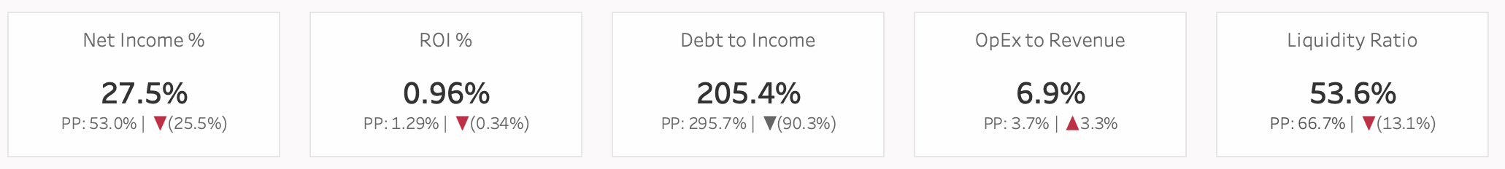

**Net Income % KPI**

1. Create the Calcs for picking up Current Period
   1. c.CP Sales = ﻿SUM(IF [c.CP Filter] THEN [Sales] END)
   2. c.CP COGS = SUM(IF [c.CP Filter] THEN ﻿[Operating Costs / COGS] END)
   3. c.CP Deprec. & Amort. = SUM(IF [c.CP Filter] THEN ﻿[Depreciations Amortizations] END)
   4. c.CP OpEx = SUM(IF [c.CP Filter] THEN ﻿[Operating Expenses] END)
   5. c.CP Taxes = SUM(IF [c.CP Filter] THEN ﻿[Taxes] END)
2. Create Current Period Net Income Calculation
   1. c.CP Net Income = ﻿[c.CP Sales] - [c.CP COGS] - [c.CP Deprec. & Amort.] - [c.CP OpEx] - [c.CP Taxes]
3. **Create the Current Period KPI**
   1. c.CP Net Income %= ﻿[c.CP Net Income]/[c.CP Sales]
4. Create the Calcs for picking up Previous Period
   1. c.PP Sales = ﻿SUM(IF [c.PP Filter] THEN [Sales] END)
   2. c.PP COGS = SUM(IF [c.PP Filter] THEN ﻿[Operating Costs / COGS] END)
   3. c.PP Deprec. & Amort. = SUM(IF [c.PP Filter] THEN ﻿[Depreciations Amortizations] END)
   4. c.PP OpEx = SUM(IF [c.PP Filter] THEN ﻿[Operating Expenses] END)
   5. c.PP Taxes = SUM(IF [c.PP Filter] THEN ﻿[Taxes] END)
5. Create Previous Period Net Income
   1. c.PP Net Income = ﻿[c.PP Sales] - [c.PP COGS] - [c.PP Deprec. & Amort.] - [c.PP OpEx] - [c.PP Taxes]
6. **Create the Previous Period sub KPI**
   1. c.PP Net Income % = [c.PP Net Income] / [c.PP Sales]
7. Net Income Change % Calculation – c.Net Income % Change = [c.CP Net Income %] – [c.PP Net Income%]
8. Create the % Change Measure compare to previous period
   1. First measure for positive change –
      1. ﻿c.Net Income Change ▲= ﻿IF [c.Net Income % Change] > 0 THEN '▲' END
   2. Second measure for negative change
      1. ﻿c.Net Income Change ▼= IF [c.Net Income % Change] < 0 THEN ﻿'▼' END
   3. Because of If condition, at a time only one calculation will display and also we have to format negative in red while showing the output, having 2 calculations ease up this front end formatting.
9. Configure the Sheet Like Below
   1. 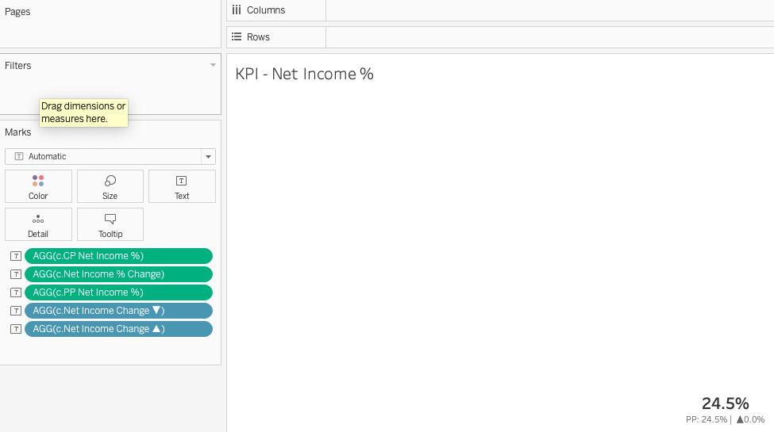
   2. Format the Text Card like this
      1. Graphical user interface, text, application, chat or text message, email

         Description automatically generated

**ROI % KPI**

1. ROI is Return on Equity i.e. Income / Equity
2. Create Current Period Total Equity KPI – Total Current Period Assets – Total Current Period Liabilities
   1. c.CP Tot Assets = ﻿SUM(IF [c.CP Filter] THEN [Assets] + [Current Assets] END)
   2. c.CP Tot Liabilities = ﻿SUM(IF [c.CP Filter] THEN [Liabilities] + [Current Liabilities] END)
   3. c.CP Total Equity = ﻿[c.CP Tot Assets] - [c.CP Tot Liabilities]
3. ﻿c.CP ROI% = ﻿[c.CP Net Income]/[c.CP Total Equity]
4. Create Previous Period Total Equity KPI – Total Previous Period Assets – Total Previous Period Liabilities
   1. c.PP Tot Assets = ﻿SUM(IF [c.PP Filter] THEN [Assets] + [Current Assets] END)
   2. c.PP Tot Liabilities = ﻿SUM(IF [c.PP Filter] THEN [Liabilities] + [Current Liabilities] END)
   3. c.PP Total Equity = ﻿[c.PP Tot Assets] - [c.PP Tot Liabilities]
5. ﻿c.PP ROI% = ﻿[c.PP Net Income]/[c.PP Total Equity]
6. ROI Change % Calculation – ﻿c.ROI % change = ﻿[c.CP ROI%] - [c.PP ROI%]
7. Create the % Change Measure compare to previous period
   1. First measure for positive change –
      1. ﻿ ﻿c.ROI Change ▲= ﻿IF ﻿[c.ROI % change] > 0 THEN '▲' END
   2. Second measure for negative change
      1. ﻿c.ROI Change ▼= IF ﻿[c.ROI % change] < 0 THEN ﻿'▼' END
   3. Because of If condition, at a time only one calculation will display and also we have to format negative in red while showing the output, having 2 calculations ease up this front end formatting.
8. Configure the sheet as shown below
   1. Graphical user interface, application

      Description automatically generated
9. Configure the Text Card as shown below
   1. Graphical user interface, text, application, email

      Description automatically generated

Debt to Income KPI –

1. c.CP Debt to Income % = ﻿[c.CP Tot Liabilities]/[c.CP Sales]
2. c.PP Debt to Income % = ﻿[c.PP Tot Liabilities]/[c.PP Sales]
3. ﻿c.Debt to Income % Change = ﻿[c.CP Debt to Income %] - [c.PP Debt to Income %]

Opex to Revenue KPI –

1. ﻿c.CP OpEx to Revenue % = ﻿[c.CP OpEx]/[c.CP Sales]
2. c.PP OpEx to Revenue % = ﻿[c.PP OpEx]/[c.PP Sales]
3. ﻿c.OpEx to Revenue % Change = ﻿[c.CP OpEx to Revenue %] - [c.PP OpEx to Revenue %]

Liquidity KPI –

1. ﻿c.CP Liquidity Ratio = ﻿[c.CP Curr Liabilities]/[c.CP Curr Assets]
2. c.PP Liquidity Ratio = ﻿[c.PP Curr Liabilities]/[c.PP Curr Assets]
3. ﻿c.Liquidity Ratio Change = ﻿[c.CP Liquidity Ratio] - [c.PP Liquidity Ratio]

**Income Statement Overview Chart**

Final Chart

1. Add the placeholder sheet which has point column (having value 1 to 8) to place the 8 labels at their correct place as shown above.
2. Join the Financial Table with Placeholder table by using custom calculation i.e. from the image below, choose “Create Custom Relationship” for both Financial and Financial Placeholder sheet and then just add 1 in both of them to create custom relationship.
   1. Graphical user interface, application

      Description automatically generated
3. Create a new sheet and set the chart type to Gantt Chart as Gant allows us to show the waterfall chart type.
4. Create a parameter ﻿p.WF Income St Label that will contain each label value. This is required so that in the Dashboard action can be set to filter the bar chart beside to it.
   1. Graphical user interface, application

      Description automatically generated
5. Create the calculated field c.WF Income Stmt Label as shown below. This will help both in filtering and placing the Labels at their location. Put this in columns and Exclude Null
   1. 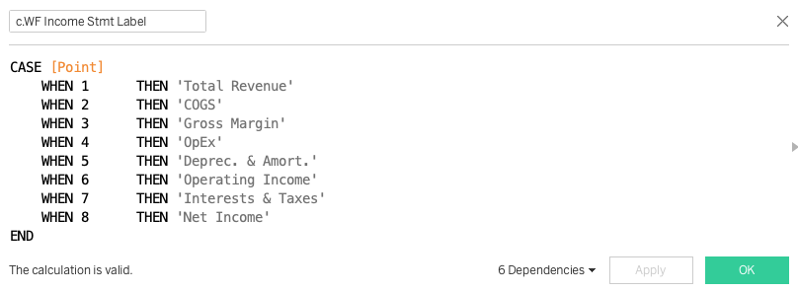
6. Create the Gross Margin and Operating Income Field which was not created earlier
   1. ﻿c.CP Operating Income = ﻿[c.CP Sales] - [c.CP COGS] - [c.CP Deprec. & Amort.] - [c.CP OpEx]
   2. c.CP Gross Income = ﻿[c.CP Sales] - [c.CP COGS]
7. Create the calculated field ﻿c.CP WF Inc Stmt Start as mentioned below and Put this on Rows. It will help adjust the location of bars based on calculation and 0 indicate to start the bar from base or 0.
   1. Graphical user interface, application

      Description automatically generated
8. Create the calculated fiel ﻿c.WF Bar Inc St Filter as mentioned below and put it on color card as it will help highlight a particular bar and the color of highlighted bar is A9CDDB and rest other is grey
   1. Graphical user interface, text, application

      Description automatically generated
   2. Graphical user interface, application, website

      Description automatically generated
9. Create the calculated field ﻿c.CP WF Inc Stmt Val as it helps shows the exact values and what is getting substracted from previous bar to show the next bar to finally show the net income.
   1. Graphical user interface

      Description automatically generated with medium confidence
10. Similar to Current Period field, create previous period field Create the calc field. This will help to calculate Change
    1. 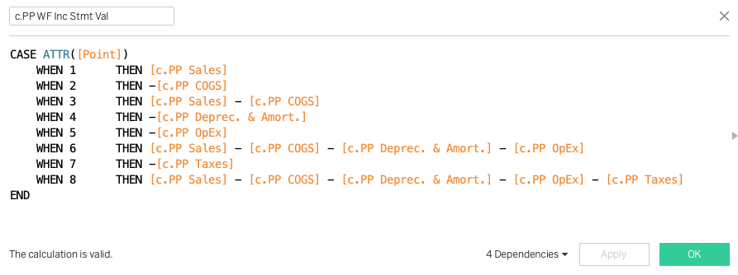
11. Put the field on size, text and tool tip card tiles as shown below
    1. Graphical user interface, text, application

       Description automatically generated
12. Finally create the ﻿c.WF Inc Stmt % Chng as per below to put it on text Tile
    1. Graphical user interface, text, application

       Description automatically generated
13. Configure the Text Tile as mentioned below
    1. Graphical user interface, text

       Description automatically generated
    2. Configure the c.WF Inc Stmt % Chng field formatting as below
       1. 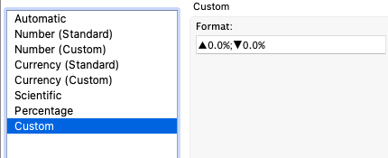
14. Final Rearrage the X Axis items manually as per the chart
15. Set the Dashboard Parameter Action as this will help change the parameter value based on bar selection in this sheet and update the another chart and here Aggregation will be set to None.
    1. 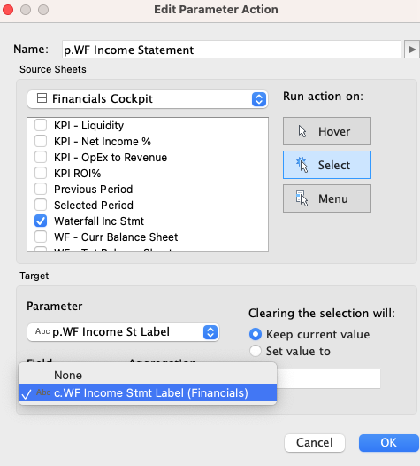

Associated filtered Chart

1. Create the Header KPI – Net Income by Company. Text color is - A9CDDB
   1. Graphical user interface, text, application

      Description automatically generated
2. Break up of each company by selected measure
   1. Chart

      Description automatically generated
   2. Measure name color
      1. Graphical user interface, text, application

         Description automatically generated
   3. Secondary axis

Dashboard Background

Balance Sheet Overview Chart

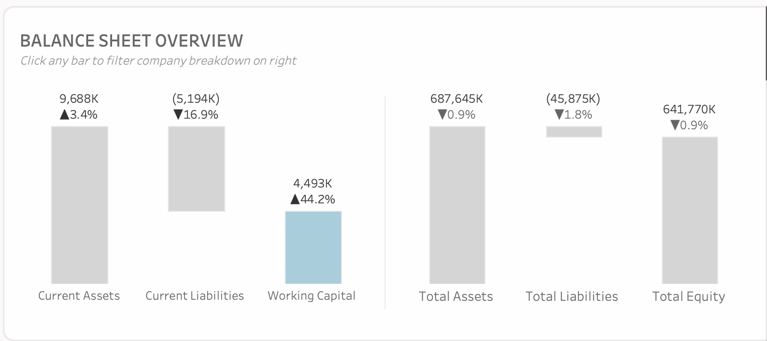

1. Balance Sheet Overview
   1. Like Previous CP and PP calculation for Current Period and Previous Period, create calc for Current Assets and Current Liabilities and Working Capital
      1. Fields are present in raw data
      2. Current Asset field is ﻿[Current Assets]
      3. Current Liabilities field is [Current Liabilities]
      4. Working Capital is Sum([Current Assets]) – Sum([Current Liabilities])
2. Calc for Total Assets, Total Liabilities and Total Equity
   1. Total Assets = Sum(Assets) + Sum(Current Assets)
   2. Total Liabilities = Sum(Liabilities) + Sum(Current Liabilities)
   3. Total Equity = Total Assets – Total Liabilities

Associated Filtered Chart

Same as Earlier Configuration.